Questionnaire for PP Woven Bags

Customer: |  |  |  |  | Date:
Contact tel: |  |  |  |  | E-mail:
AD*STAR Valve |  | AD*STAR Open |  | Flat, Leno / Mesh |  |  |  | Flat with gussets | Flat with gussets  and valve
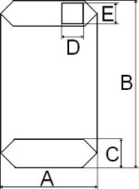 |  | 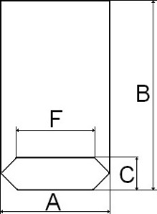 |  |  |  |  |  | 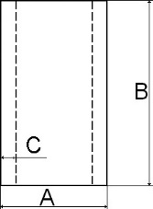 | 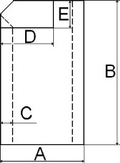
Type 1 |  | Type 2 |  | Type 3 |  |  |  | Type 4 | Type 5
Technical data |  |  |  |  |  | Indicator values
*Bag type |  |  |  |  |  |  |  |  |  | [1-5]
*Filling product
*Filling product weight |  |  |  |  |  |  |  |  |  | [kg]
*Filling product bulk weight |  |  |  |  |  |  |  |  |  | [kg/m³]
Trade mark / cliché name
*Top single hemming stitch |  |  |  |  |  |  |  |  |  | [yes / no]
*Gussets |  |  |  |  |  |  |  |  |  | [yes / no]
*Sizes |  |  | Bag width A |  |  |  |  |  |  | [cm]
 |  |  | Bag length B |  |  |  |  |  |  | [cm]
 |  |  | Bottom width C |  |  |  |  |  |  | [cm]
 |  |  | Gussets width C |  |  |  |  |  |  | [cm]
 |  |  | Valve length D |  |  |  |  |  |  | [cm]
 |  |  | Valve width E |  |  |  |  |  |  | [cm]
*Printing |  |  |  |  |  |  |  |  |  | [yes / no]
Printing colors quantity |  |  |  |  |  |  |  |  |  | [0-6:6-0]
*Perforation/Microperforation |  |  |  |  |  |  |  |  |  | [yes / no]
*Lamination |  |  |  |  |  |  |  |  |  | [yes / no]
Fabric weight |  |  |  |  |  |  |  |  |  | [g/m²]
Lamination weight |  |  |  |  |  |  |  |  |  | [g/m²]
*Total bag weight |  |  |  |  |  |  |  |  |  | [g/m²]
Bag weight |  |  |  |  |  |  |  |  |  | [g]
Bag color
Transparent strap |  |  |  |  |  |  |  |  |  | [yes / no]
Transparent strap width |  |  |  |  |  |  |  |  |  | [cm]
*UV stabilization |  |  |  |  |  |  |  |  |  | [yes / no]
Handle (for AD*STAR Open, Flat bags) |  |  |  |  |  |  |  |  |  | [yes / no]
Innerliner (for Flat bags) |  |  |  |  |  |  |  |  |  | [yes / no]
Twine (for leno / mesh bags)
*Total bag quantity |  |  |  |  |  |  |  |  |  | [pcs]
*For pricing you should fill in all the marked lines.

